


With thanks to Friends Provident for the use of their facilities
www.friendsmilestones.com
MOLE VALLEY ORIENTEERING CLUB

NATIONAL EVENT

SUNDAY 25th FEBRUARY 2007
WHITE DOWNS - DORKING

FINAL DETAILS

Important points
If you only remember one paragraph of these details, make it this one
- this event uses SI punching
- there is a bus journey from the event centre to the competition area, your allocated start time is the time you need to start your run, not the time you need to catch the bus
- bring your own bag for the clothing dump
- whistle recommended, cagoule may be compulsory
- changing rooms and hot showers are available, add soap, towel and clean clothes to your normal O-kit
and reread the bit headed “terrain and courses” before you go.

Competitions
This events counts for the Future Champions Cup, Masters Cup, National Rankings, South-East League and South-East Galoppen, and is a selection race for the England Veteran Home International team.

Venue
Event Centre at Friends Provident (FP), Dorking. Grid Reference TQ 172 506. We have been given permission to use the FP Social Club as an event centre, but please note that the main office buildings are strictly out-of-bounds. Facilities include tarmac car-park, changing rooms, showers and bar.

Travel by road
From M25, exit at junction 9 and head south on A24 for “Dorking”. After 5 miles, reach a roundabout sign with a brown “vineyard” panel inset. Turn left (away from the vineyard), then immediately right into Friends Provident. Continue to main car park (see map attached).

From A24/A25 junction on the eastern edge of Dorking, head north on A24 for “London”. After 800 metres reach “vineyard” roundabout (see above). Turn right and right again.
“O” signed from “vineyard” roundabout.

Travel by rail
For once the event centre is easily accessible by rail, with two stations within 400 metres. Dorking station is terminus for a half-hourly service from Victoria via Clapham Junction, Sutton and Epsom. Exiting the station, the more pleasant route is to turn left immediately into a car park (before the main road). At bottom of this car park, turn left under the railway and left again into the FP car park (this route for pedestrians only).
Dorking Deepdene station is a stop on the hourly service between Gatwick and Reading via Redhill and Guildford. From Deepdene, turn right onto the main A24 road for 100 metres, then sharp right into Lincoln Road, under a railway line and then follow left into the FP car park.
Alternative route from either station is to follow the A24 to the event bus stop.

Travel by air
Gatwick Airport is nearest, then about 25 minutes by train to Deepdene.

Car parking
We are able to use the normal staff car parking facilities, although spaces close to the main building must be kept clear. Please park as directed, keeping to marked spaces where present. There will be no charge for car parking. Overflow car parking will be available in the local area. This may need to be used by late comers if the Friends Provident parking facilities are insufficient. There will be adequate space for larger vehicles (camper vans, minibuses and motor homes). Please contact the Organiser in advance if you are bringing a coach.

Event Centre
All facilities are located inside the FP Sports & Social Club. This includes Enquires, Registration, Download, display of start lists and results, toilets, changing rooms, showers, comfy chairs and bar.

You may download wearing orienteering shoes. Otherwise, dirty or studded shoes are not permitted indoors. It is however acceptable to walk through to the toilets or changing rooms in wet or muddy socks. The gents facilities have direct access from outside; for the ladies it is necessary to use the main social club entrance and climb the stairs. There is plenty of hot water, but please turn your shower off when you have finished – unlike many club showers, there is no time switch and the water will keep flowing until you stop it.

There are toilets close to the bar, but don't queue for these as most toilets are in the changing rooms.

A limited number of coin-operated (20p non-refundable) lockers are available, otherwise kit may be left in the changing rooms at your own risk. Small items such as car keys may be left at enquiries. Please put them in an envelope with your name on it.

Other facilities of the Social Club such as the bar and pool and table football machines (50p) will be available, but only for people wearing clean clothes please. The bar will be open from mid-day serving cold drinks, alcoholic and otherwise. Children are welcome in the bar, but obviously must not consume alcohol. Friends Provident have been very helpful providing these facilities so please spend some money to encourage them.

Ultrasport, Compass Point and Wilf’s will be attending – see site plan. You may take your Wilf's meal into the bar to eat in comfort (provided you have changed).

Recent heavy rain has saturated the lawns, so please keep off the grass at all times. Children (and adults) are welcome to kick a ball around in the FP sports field (see “String course” on site plan), but parents should note that this is across a public road; also at the far end of the field is the River Mole, which is in spate and well capable of drowning anyone who falls in.

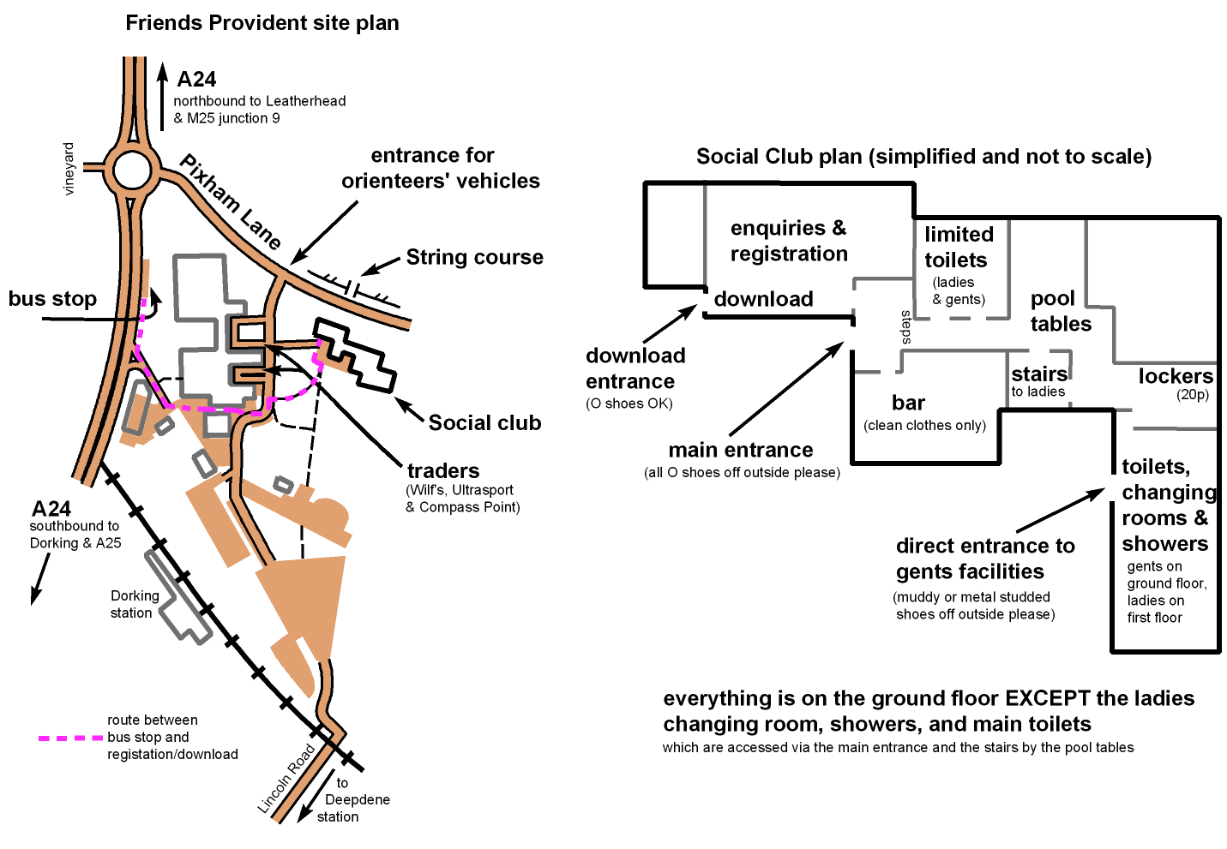
Safety and First Aid
First Aid will be provided by St John Ambulance at the Finish. There will be no special First Aid provision at the Event Centre. Remember that competitors take part at their own risk and are responsible for their own safety. You are strongly recommended to carry a whistle. In adverse weather, the organiser may either recommend or require that competitors carry or wear cagoules – please come prepared. If you are travelling alone please leave car keys (or return rail ticket) at Registration in an envelope marked with your name.

Please download immediately you get off the bus back at the Event Centre, even if you have retired. This is our only check that you are not still in the forest.

Registration
Will be situated in the Social Club and will handle entry on the day for colour-coded courses. It will be open from 9:15 to 12:00. Start times 10:00 to 13:00. Fees: Senior BOF full members/SEOA local members £6, other seniors £8, Juniors/Students £3. Premarked maps will be used. There will be no entry-on-the-day for National Event courses.

National Event competitors who have pre-hired SI cards should collect them from Registration. If you have not already paid the hire fee please bring £1 per card with you. Colour Coded competitors will be able to hire SI cards on the day for £1 per card. If you lose your hire card, it will cost £20.

National Event competitors who have their own SI-cards may go straight to their starts – there is no need to visit registration.

Transport to the competition area
All courses except String are a bus ride away. See site plan for the bus stop, which will be used both to pick up before your run and set down afterwards. Parents should be aware this is adjacent to a busy main road. Due to the saturated state of the ground, please keep off the lawn and follow a tarmac route to the bus stop.

Buses will run at intervals of 10 to 15 minutes and the journey time is about 15 minutes. The start is 100m from the drop off point, the finish a further 150m in the same direction.

Remember your SI card, compass, whistle, loose control descriptions, cagoule (if required) and clothing-dump bag before you get on the bus.

Starts
One start for all courses (except String which is at the Event Centre). A quiet start will be in operation. Start officials will not call out start times or shout out the names of starters. It will be competitors own responsibility to look at the clock which will be in the pre-start area and ensure they are checked through the start system at the appropriate time. Call-up will be at – 3 minutes, and you will be timed from your start time as listed in the start lists. There will be no allowance for late starters who will be accommodated at the discretion of the start officials. Exceptional arrangements may be made for second split start runners or any others unavoidably delayed by circumstances caused by the organisation of the event.

Blank maps will be displayed in the start lanes. Competition maps will be positioned after the start line and picked up by competitors in race time. Assistance / following juniors is not allowed on National Event courses, and is only allowed on colour-coded courses after any competitive run on a National Event course (not before).

There will be a marquee near the start to shelter you while you wait for your time, also a clothing dump – bring your own bag - and limited portable toilets. Please give priority for the toilets first to start and finish officials, and secondly to anyone whose start time is imminent. There will be a drinks station available at the pre-start; this will be shared with people who have finished, and you are reminded that you must not look at a map or discuss a course before you start.

A public bridleway passes through the pre-start area. Please take care not to frighten any horses, both here and out in the forest. Please also do not allow your children to climb on stacks of loose logs.

Finish
One finish for all courses, close to the start. Remember to collect any dumped clothing before getting back on the bus. Please don't allow people yet to start to see your map, or discuss your course within their hearing.

Download
It is essential that all competitors download their SI cards at the Event Centre as soon as they arrive back. You will be directed to download on arrival, located in the Registration room. Please download as soon as you return and before you get changed. If you do not download we may think you are still out on your course and feel obliged to mount a search party

Do not use any of the other facilities in the Sports Club after downloading until you have changed your shoes. Do not use the comfy chairs until you have changed your clothes too.

Results
Results will be displayed at the Event Centre during the course of the event and will be published on the Mole Valley Web site (www.mvoc.org) as soon as possible after the end of the event.

Complaints / Protests
If any competitor wishes to lodge a complaint this should be done to the Organiser. If, following the Organiser' decision, the competitor wishes to lodge a protest against that decision, the protest should be made in writing to the Organiser with a fee of £5 (refundable if the protest is upheld). A jury will decide on the validity of the protest and the action to be taken.

Terrain and courses
White Downs is part of the North Downs chalk hills, and features the characteristic east/west ridge, with a steep scarp slope to the south, and gentle dip slope to the north. Almost all the competition area is wooded. The woodland is extremely varied, ranging from ancient bluebell wood to managed plantation. Even the plantations are variable, some deciduous, some coniferous, many quite mature with large trees. There are some areas of brashing or undergrowth, but much of the forest is very runnable. Don't be put off by the brambles in the pre-start area, there are none so bad on the courses.

January gales gave White Downs a vigorous shaking. There is now a lot of dead wood on the ground. Most has little effect on runnability, but everybody will encounter new fallen trees. Fortunately, most of these are isolated and easily circumnavigated. There are a few patches of windblow in the eastern part of the area. The map has been updated, although individual fallen trees are not usually mapped.

Please can parents make children aware that they will encounter recently fallen trees. This applies on all courses, even 18 & 17 (White & Yellow). On these courses, while the tracks may at first sight appear to be blocked, it is easy to divert around the trees without losing sight of the track.

There are some fenced enclosures on the scarp slope to the south of the area. Work is in progress to remove old fences and replace them with new ones, in roughly the same place. Competitors on courses 1-16 should be aware that mapped fences may have disappeared, while new ones may have appeared. This applies particularly to course 16, which is the only one likely to cross a new fence. At this point, competitors should be following the North Downs Way, so there will definitely be a stile or gate.

Courses 16-18 have no road crossings.

All other courses cross one road twice. There are no defined crossing points, and consequently no road crossing marshals. Traffic is light, so competitors should not be significantly delayed by traffic, nevertheless you must be prepared to slow down and perhaps stop to cross safely. Watch out in particular for push-bikes descending fast and silently.

A section of the road is on a steep hill; this is a “sunken lane” with precipitous banks down to the road. This will be marked with yellow/black tape on the west side (from which you would be approaching). There is no formal restriction on crossing the road, but courses have been planned so that it will be quicker (or so the planner believes) for you to stay in the forest until you reach the upper end of the tape. Even at the end of the tape, there is a significant step down to the tarmac, so be careful. If you do choose to cross the tape, take extreme care to avoid committing to sliding down the bank and onto the road ahead of a vehicle.

Some courses have a leg parallel to the road; planner's advice is that this is a particularly fast section of forest and diverting to run along the road would cost you time.

Courses 1-4, 8 & 9 enter an area of the forest used for pheasant shooting, and closed to the public. “Private Keep Out” and similar notices may be ignored. Competitors may encounter pheasant-rearing pens, which are enclosures of 2.5m-high wire mesh fences, mapped with the “high fence” symbol. These are currently empty; last season's stock has already been shot, and next season's has yet to arrive. Although not mapped as such (for clarity), these pens shall be regarded as out-of-bounds.
There is normally fast running along the outside edge of a pheasant pen, but watch out for support wires.

Competitors on courses 1-3 and 8 may encounter a small market garden in the forest! This is a clearing, containing pens for ducks and chickens. These pens are covered, and apparently if anyone runs close the stupid birds will fly up and mangle themselves in the roof. Consequently the entire clearing must be avoided. It is surrounded by a low hedge made of dead wood, which shall not be crossed by competitors, and marked on the map with purple out-of-bounds overprint.

Courses close at 15:00 but controls will be progressively removed before then.

Mappers Notes
Special Symbols:

Black T : A shooting platform, usually against a tree but in some cases lying on the ground
Black O: A wrecked car (4 wheel drive – goody-goody!!)
Black X : A branch hide or crude shelter (with corrugated roof)
Brown X: Large animal diggings (badger setts usually)
Blue X: Water Trough

The January storms resulted in some trees coming down. There are three areas of significant damage, one large and two smaller. The larger area has been marked as fight and/or walk but there are ways through. One of the smaller areas is near to the finish and the trees still causing obstructions to the paths and in the vicinity of the controls have been marked as long thickets (between 20 and 35 metres long), some of which overlap. There are many other fallen trees, both recent and otherwise, that have not been mapped.

There are three areas of recent forest harvesting which have been mapped as “slow undergrowth” to indicate that they are not a fast as the adjacent woodland.

Map

Surveyed and drawn by Mike Elliot during winter 2006/7 based on previous maps of White Downs and Ranmore Common. 1:10,000 and 1:15,000 with 5m contours. Maps will be printed on waterproof paper. The maps will not be bagged but some may like to take plastic bags to protect them from mud or blood. Suitable bags will be available in the pre-start area.

Control Descriptions

IOF pictorial Control Descriptions will be on the front of the map for all courses. Loose Control Descriptions may be downloaded from the web a few days before the event, or collected from Registration. Pictorial descriptions will be available for all courses, also text descriptions for courses 7, 15 – 18, and colour-coded.

Course details
Course | Scale | Length (km) | Climb (m) | Controls | M classes | W classes | Colour-coded
1 | 1:15,000 | 11.9 | 300 | 26 | M21L
2 | 1:15,000 | 10.0 | 275 | 22 | M20L, M35L, M40L
3 | 1:15,000 | 8.6 | 170 | 18 | M18L, M21S | W21L
4 | 1:15,000 | 6.9 | 145 | 17 | M16A, M20S, M35S, M40S | W20L, W35L, W40L
5 | 1:15,000 | 5.7 | 110 | 12 | M18S, M21V | W18L, W21S
6 | 1:15,000 | 5.2 | 75 | 11 |  | W20S, W35S, W40S
7 | 1:10,000 | 6.2 | 110 | 19 | M21N |  | Red
8 | 1:10,000 | 8.6 | 165 | 17 | M45L, M50L
9 | 1:10,000 | 6.8 | 150 | 16 | M55L, M60L
10 | 1:10,000 | 5.7 | 100 | 14 | M65L, M45S, M50S | W45L, W50L
11 | 1:10,000 | 5.2 | 80 | 10 | M70L, M55S, M60S | W16A, W55L, W60L
12 | 1:10,000 | 4.2 | 75 | 10 | M75L, M65S | W65L, W70L, W18S, W21V, W45S, W50S
13 | 1:10,000 | 3.5 | 40 | 9 | M70S, M75S | W75, W55S, W60S, W65S, W70S
14 | 1:10,000 | 4.4 | 105 | 11 | M14A, M16B
15 | 1:10,000 | 4.0 | 75 | 10 |  | W14A, W16B | Light Green
16 | 1:10,000 | 3.0 | 65 | 11 | M12A, M14B | W12A, W14B, W21N | Orange
17 | 1:10,000 | 2.9 | 55 | 11 | M10A, M12B | W10A, W12B | Yellow
18 | 1:10,000 | 1.9 | 45 | 13 | M10B | W10B | White

String course
The String course will be in the FP sports field, 50m from the Event Centre building, (see site plan) and will be open between 10.00 and 12.00 only. Free entry at the special registration point. Parents should note that a public road must be crossed to reach the string course; also although well away from the string course, at the far end of the field is the River Mole, which is in spate and well capable of drowning anyone who falls in. The course will be passable for pushchairs.

Dogs
Are not welcome in the Event Centre and are not allowed on the buses, so we recommend that they should be left at home if possible.

Severe weather
There are two forms of severe weather which could cause cancellation of this event. Further storm winds might demolish the forest, or render it unsafe to enter on the day. Snow could make the road to the competition area impassable for buses. If either of these seems likely, a notice will be placed on the MV web site and kept as up to date as possible. There is no risk of this event being jeopardised by heavy rain or floods. See comments in the Safety section regarding cagoules.

Make a weekend of it: JOK are running their annual Chasing Sprint six miles away on Saturday.

Officials

Organiser: Michael White: tel 01306 888886 (before 9pm), or email mandj@white1966.freeserve.co.uk
Planner: Ian Ditchfield
Controller: Dave Stubbs (BKO)

For any further information see MV web site: www.mvoc.org.

ALL COMPETITORS TAKE PART AT THEIR OWN RISK AND ARE RESPONSIBLE THEIR OWN SAFETY

